**Name: Omer Hafeez**

**Roll No: 22i 1859**

**Section: DS A**

**2:**

**CREATE Table employee_new(employee_id int(20), employee_name varchar (50), last_name varchar (50), email varchar (50), phone_number varchar (50),hire_date date ,job_id varchar (50),employee_salary decimal (5,2),commission_pct decimal (5,2), manager_id int);**

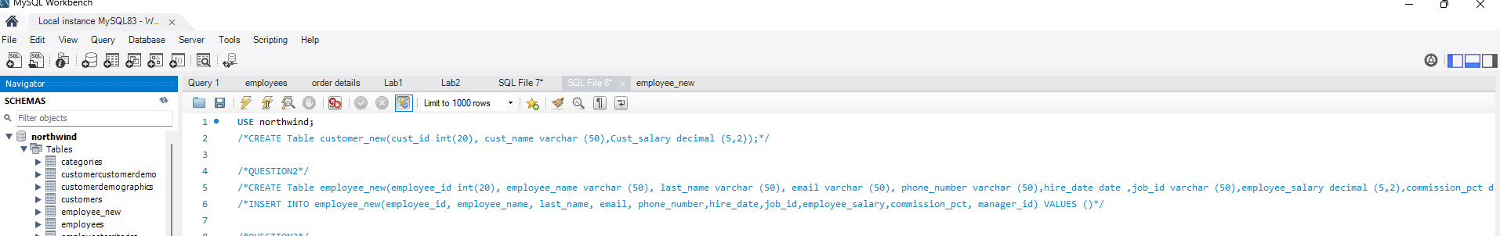

3:

ALTER TABLE employee_new

RENAME employee_old;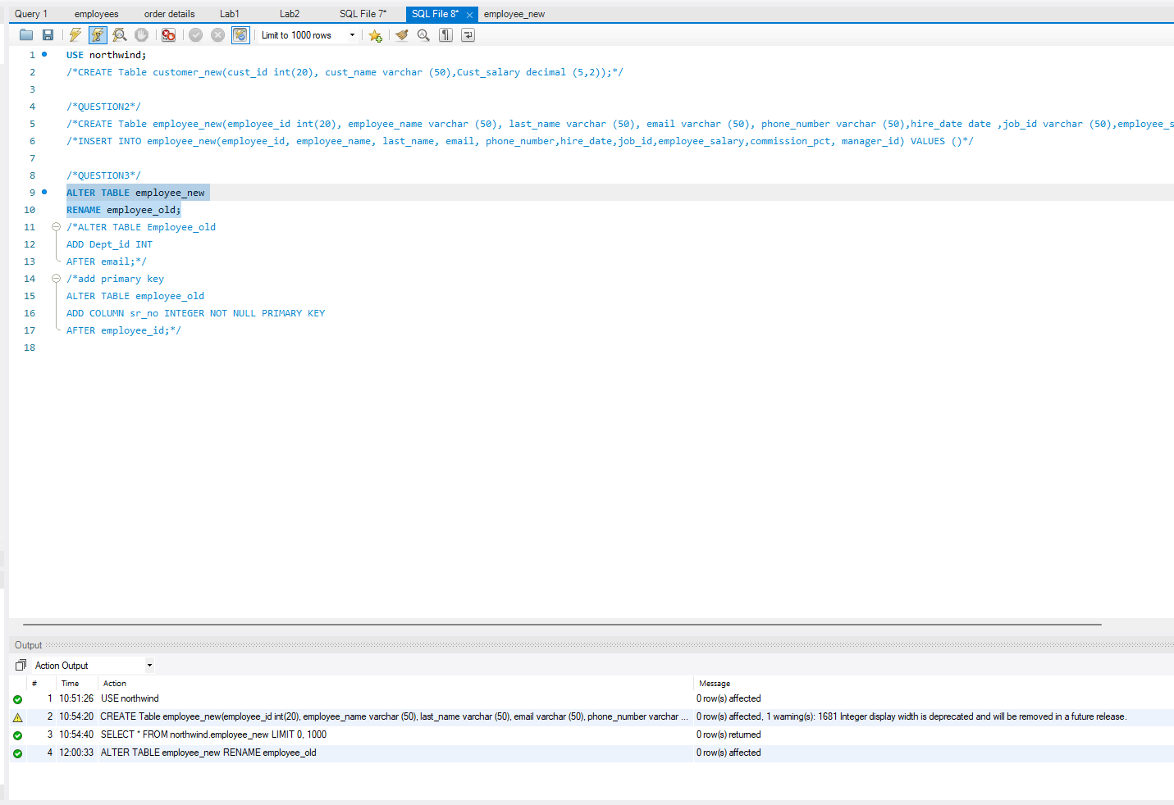

ALTER TABLE Employee_old

ADD Dept_id INT

AFTER email;

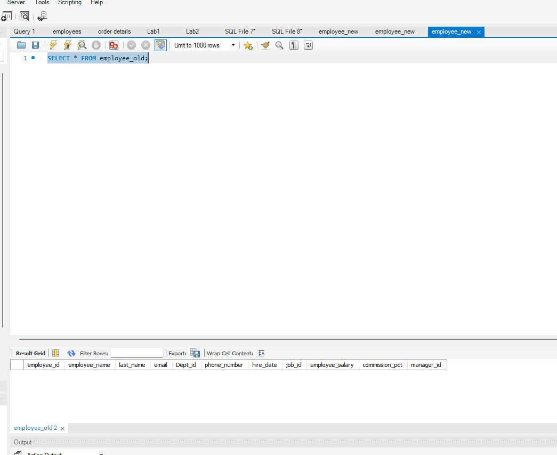

ALTER TABLE employee_old

MODIFY COLUMN phone_number int;

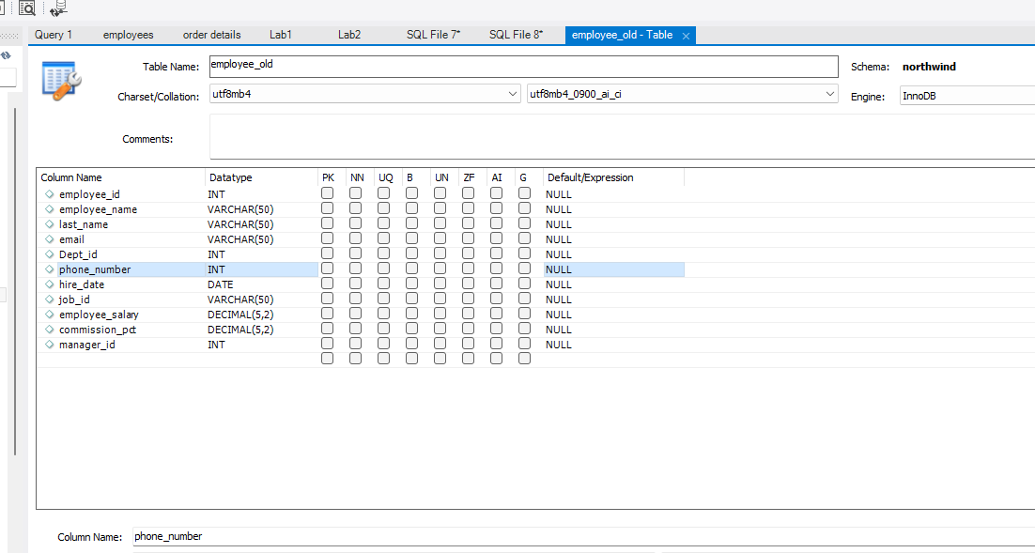

ALTER TABLE employee_old

ADD COLUMN sr_no INTEGER NOT NULL PRIMARY KEY

AFTER employee_id;

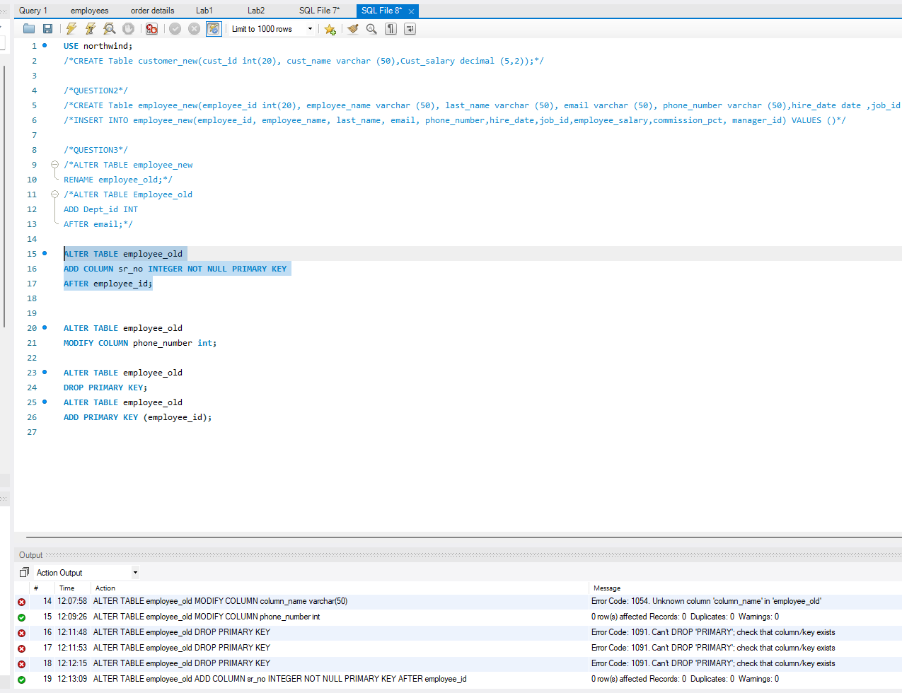

ALTER TABLE employee_old

DROP PRIMARY KEY;

ALTER TABLE employee_old

ADD PRIMARY KEY (employee_id);

ALTER TABLE employee_old

DROP sr_no;

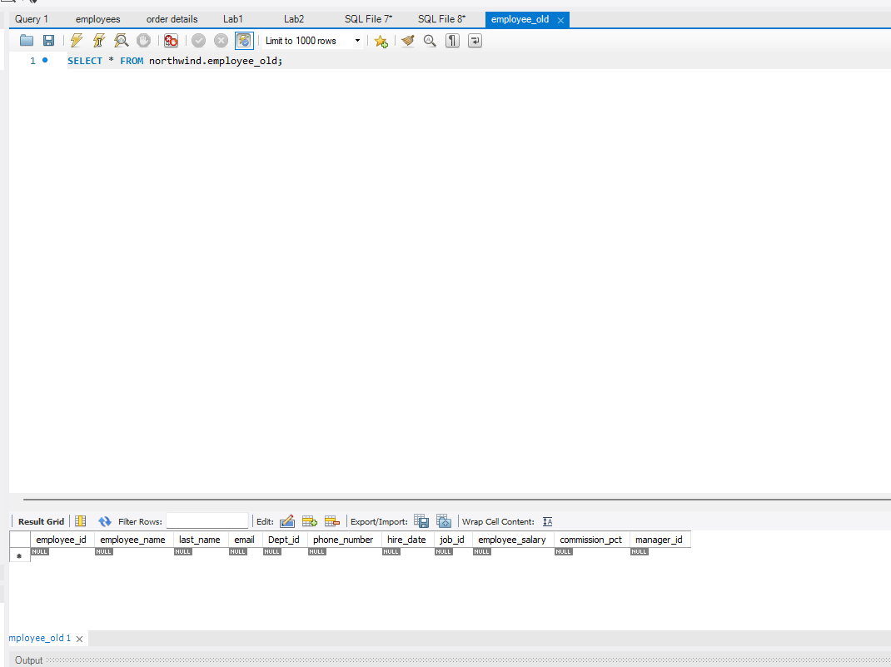

ALTER TABLE employee_old

ADD CONSTRAINT email_unique UNIQUE (email);\

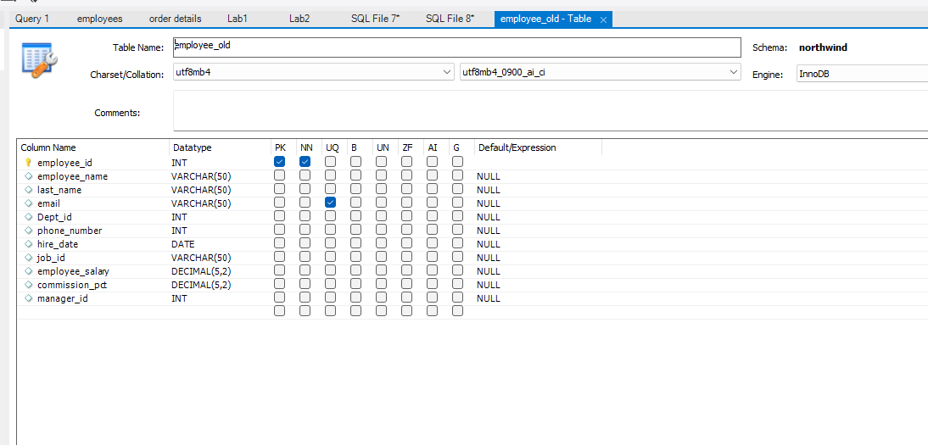

ALTER TABLE employee_old

ADD CONSTRAINT fk_dp_id FOREIGN KEY (dept_id) REFERENCES orders(OrderID);

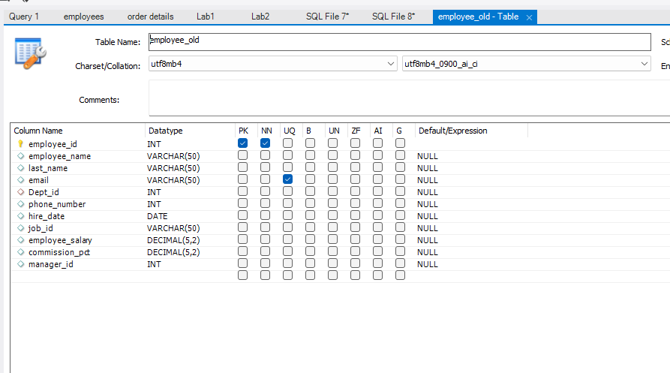

**4:**

INSERT INTO employee_old(employee_id, employee_name, last_name, email, phone_number, hire_date, job_id, employee_salary, commission_pct, manager_id)

VALUES

(100, 'Omer', 'Hafeez', 'ome', '1234', '1987-06-17', 'AD_PRES', 310.00, 0.00, NULL),

(101, 'Abubakkar', 'Hafeez', 'bakkar', '5678', '1989-09-21', 'AD_VP', 356.00, 0.00, 100),

(102, 'Usman', 'Hafeez', 'usm', '91011','1993-01-13', 'AD_VP', 572.00, 0.00, 100),

(103, 'Ali', 'Hafeez', 'al', '121314', '1990-01-03', 'IT_PROG', 239.00, 0.00, 102),

(105, 'Safwan', 'Usama', 'saf', '5265', '1997-06-25', 'IT_PROG', 134.00, 0.00, 103);

UPDATE employee_old

SET phone_number = 151617

WHERE employee_id = 105;

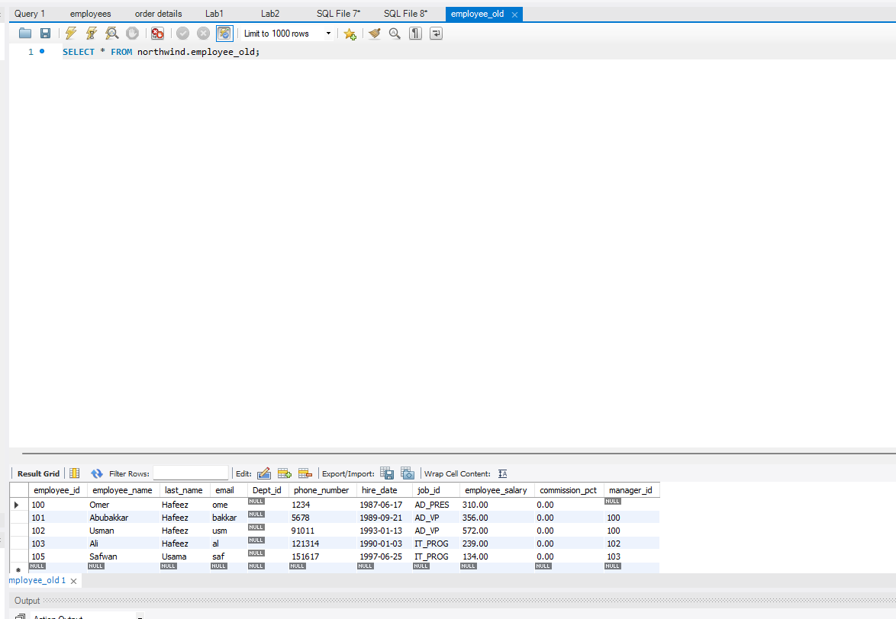

5:

INSERT INTO customers(CustomerID, CompanyName, ContactName, ContactTitle, Address, City, Region, PostalCode, Country, Phone, Fax)

VALUES ('CUST1', 'Alfreds Futterkiste', 'Maria Anders', 'Sales Representative', 'Obere Str. 57', 'Berlin', NULL, '12209', 'Germany', '030-0074321', '030-0076545');

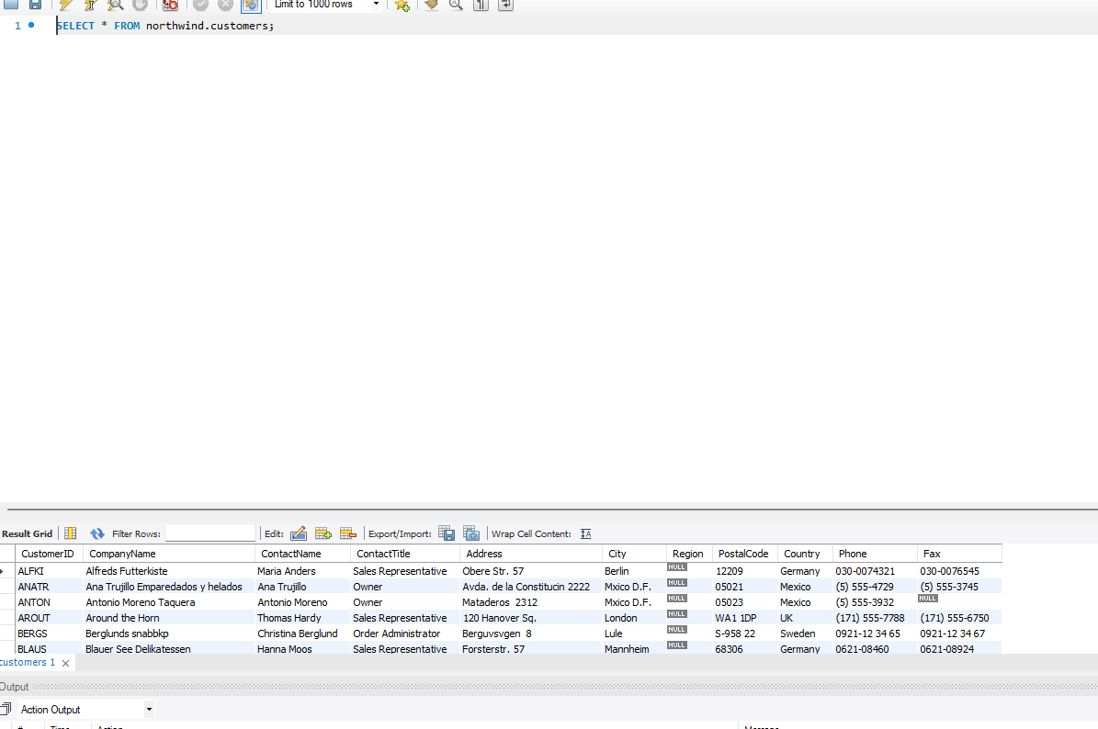

UPDATE `order details`

SET Quantity = 10

WHERE OrderID IN (SELECT OrderID FROM orders WHERE CustomerID IN (SELECT CustomerID FROM customers WHERE country = 'USA'));

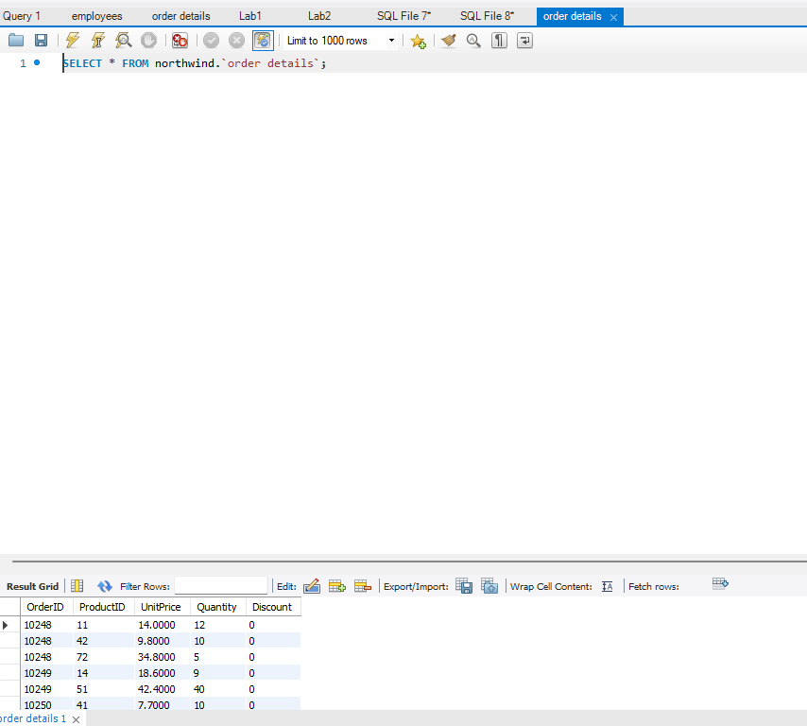

DELETE FROM `order details`

WHERE OrderID IN (SELECT OrderID FROM orders WHERE CustomerID IN (SELECT CustomerID FROM customers WHERE country = 'USA') AND ShippedDate IS NULL);

